Useful information
We strongly believe that your child’s education should be a partnership between parents/ carers and school and that communication is vital in supporting your child throughout their time at Worthington. We have an open-door policy where parents/ carers are welcome to make an appointment to meet with teaching staff or the SENDCo and discuss your child’s progress. We recommend speaking to your child’s class teacher in the first instance.

Please find below further support that is on offer through Trafford:
Trafford SEND Local Offer
https://www.trafford.gov.uk/residents/children-and-families/special-educational-needs-and-disability/special-educational-needs-and-disability-SEND-local-offer.aspx


Trafford SEND Information Advice and Support Services (SENDIASS)
https://sendiass.trafford.gov.uk/Home.aspx
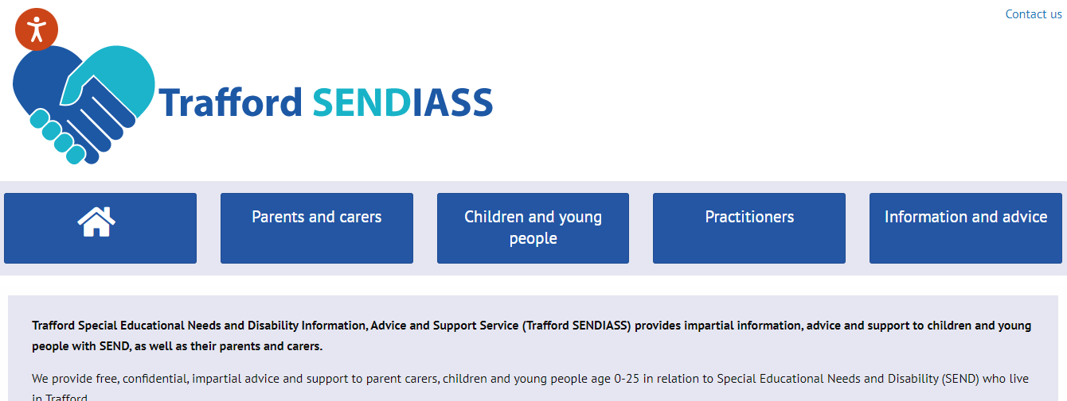

Trafford Family Information Service
Offers free, impartial advice and guidance service as well as local support services and things to do.
https://www.trafforddirectory.co.uk/kb5/trafford/fsd/home.page

Trafford Parents Forum
Trafford Parents Forum supports parent carers and families of children and young people with SEND across Trafford.
https://www.traffordparentsforum.com/


Trafford Autism Hub
https://www.trafforddirectory.co.uk/kb5/trafford/fsd/advice.page?id=5W9xRU_P_7U
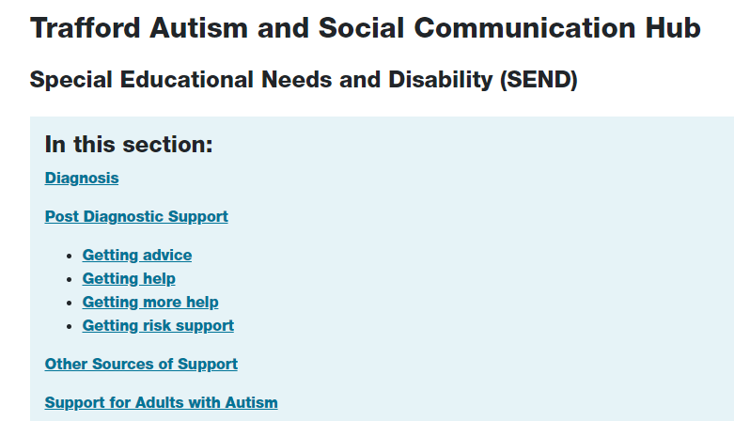

STEP Stronger together, empowering parents forum
https://www.trafforddirectory.co.uk/kb5/trafford/fsd/service.page?id=ZhVo9t8DDmU
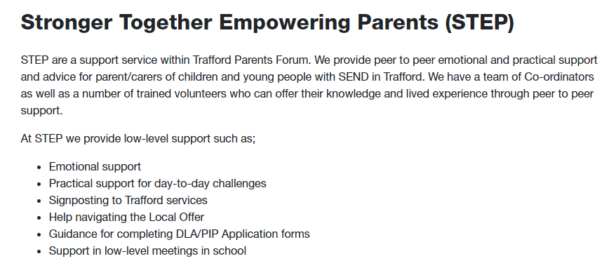
Trafford Sunrise – Just psychology
Website not working
Trafford Sleep Services
https://sleepandtherapyservices.co.uk/service/trafford-sleep-services/


